The clicker is a small noisemaker that makes a distinctive "click" sound when the metal tab is pressed. The clicker is intended to tell your dog when he or she does something correctly. Once you've trained your dog to associate the clicker with rewards, he will quickly learn that when he performs a behaviour and you click, he will receive a reward. This means that your dog will be an active participant in the training process, instead of just being forced into position.
Here we have a photo of both of my clickers, 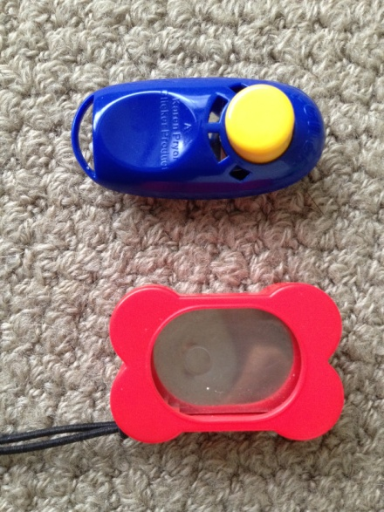
The red clicker (on the bottom) is a box clicker, where you have your thumb on the metal, on the opposite side to the circle. The box clicker produces a rather loud click, and is great for outdoors work where there may be a lot of environmental noise. The box clicker can be a little bit awkward as you must have the clicker the right way up and with the correct orientation with your thumb inside the box.
The blue clicker (on the top) is a button clicker (The i-Click). The great thing about this button clicker is that it was designed by the clicker trainers, it has a quiet click. Dogs who are sound sensitive dogs or when the clicker will be close to your dog's head. Please note: animals that have been trained with a classic box clicker will also fully understand the lighter sound of the button clicker. It has been designed to let you click no matter how you happen to grab hold of it. Upside down click, sideways click, right side up click. You can click with your thumb, with your palm, even your foot. And no more worries about clicking with your gloves on, if you suffer from arthritis or if you have long nails or large hands. Balanced Clicking. The trigger has been engineered so that a small amount of pressure is all you need to click, but you aren’t likely to click early or mistakenly either. Right Sized. The i-Click is small enough to be hidden in your palm; not only does this make it wonderfully discreet, but you can click in that position! This means you never need fret about the clicker becoming a visual cue.
I think you can tell which my favourite is!
I have the two clickers one for agility and one for obedience and close working efforts. I use the box clicker for agility because it’s louder, and the button clicker for obedience because it is quieter, - I do much prefer the button clicker. You may hear “you should always train your dog with your one clicker” I do not believe this should be the case, what happens when you are at class and need to borrow a clicker? If used correctly your dog will not notice the change of click.
Clicker fundamentals
I will go over how to use the clicker in Clicker Training
However first I want to give you the essentials of training with a clicker.
The clicker is based on positive reinforcement, so therefore NO negative should come from it.
With the clicker we are always striving for that ‘better’ response, and building on the behaviour that we already have to create new ones.
The click means = your reward is coming, whether that is a game of tug or food, whichever is best for the situation and your dogs drive.
I use a (box) clicker for teaching agility where the reward will be a good game of tug, or a throw of the ball, because she is super excited and I usually need to reward at the end of a session or weaves, therefore I can break her off and reward her.
I use a (button) clicker for teaching obedience where the reward is usually food, because she will be thinking a lot harder about her body position – and that is exactly what I want to reward.
I recommend that you always hold your clicker behind your back, so the clicker isn’t eliciting the behaviour.

